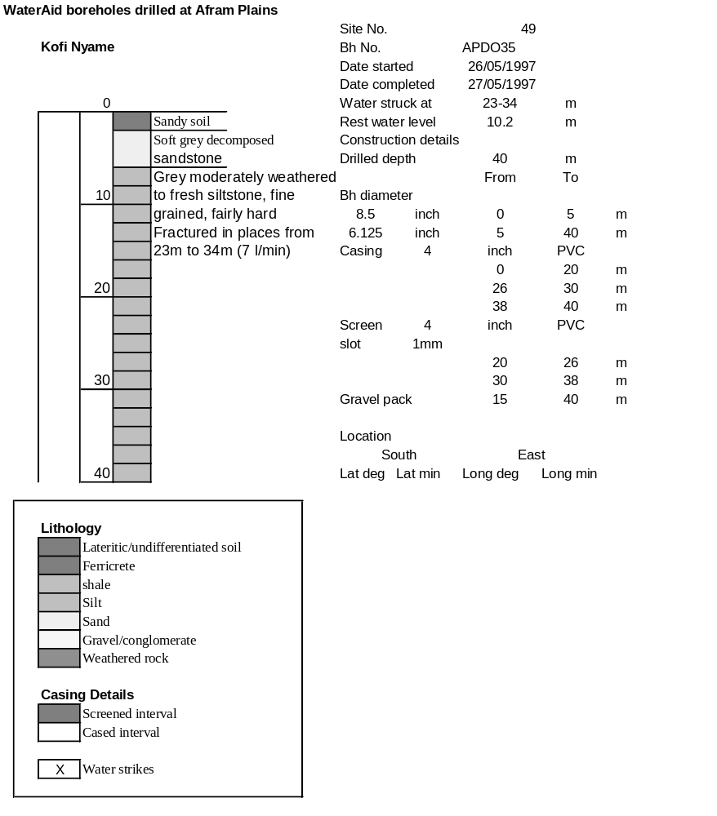

Ghana | Test pumping
Borehole No. |  | APDO 35
Hole No |  | 49
Village |  | Kofi Nyame
Date |  | 18/06/1997
Point below GL |  | 0.68 | m
Pump depth |  | 30 | m
SWL |  | 10.2 | m
Start Time |  | 21:00
Drawdown test |  |  |  |  | Recovery Test
time | pwl | Q l/min | dd | sc(q/s) | Time | wl | t/t' | resdd
0.00 | 10.20 | 4.80 | 0.00 |  | 0.00 | 30.01 |  | 19.81
1.00 | 17.12 | 4.80 | 6.92 | 0.69 | 1.00 | 29.70 | 91.00 | 19.50
2.00 | 17.14 | 4.80 | 6.94 | 0.69 | 2.00 | 28.60 | 46.00 | 18.40
3.00 | 17.24 | 4.80 | 7.04 | 0.68 | 3.00 | 27.15 | 31.00 | 16.95
4.00 | 17.44 | 4.80 | 7.24 | 0.66 | 4.00 | 26.17 | 23.50 | 15.97
5.00 | 17.64 | 4.80 | 7.44 | 0.65 | 5.00 | 25.70 | 19.00 | 15.50
6.00 | 17.84 | 4.80 | 7.64 | 0.63 | 6.00 | 25.15 | 16.00 | 14.95
7.00 | 18.50 | 4.80 | 8.30 | 0.58 | 7.00 | 23.21 | 13.86 | 13.01
8.00 | 18.86 | 4.80 | 8.66 | 0.55 | 8.00 | 23.15 | 12.25 | 12.95
9.00 | 19.39 | 4.80 | 9.19 | 0.52 | 9.00 | 22.89 | 11.00 | 12.69
10.00 | 19.81 | 4.80 | 9.61 | 0.50 | 10.00 | 22.55 | 10.00 | 12.35
12.00 | 20.37 | 4.80 | 10.17 | 0.47 | 12.00 | 22.32 | 8.50 | 12.12
14.00 | 20.39 | 4.80 | 10.19 | 0.47 | 14.00 | 21.92 | 7.43 | 11.72
16.00 | 20.86 | 4.80 | 10.66 | 0.45 | 16.00 | 21.80 | 6.63 | 11.60
18.00 | 20.93 | 4.80 | 10.73 | 0.45 | 18.00 | 21.20 | 6.00 | 11.00
20.00 | 21.01 | 4.80 | 10.81 | 0.44 | 20.00 | 20.00 | 5.50 | 9.80
25.00 | 21.40 | 4.80 | 11.20 | 0.43 | 25.00 | 18.72 | 4.60 | 8.52
30.00 | 21.48 | 4.80 | 11.28 | 0.43 | 30.00 | 18.15 | 4.00 | 7.95
35.00 | 21.49 | 4.80 | 11.29 | 0.43 | 40.00 | 17.84 | 3.25 | 7.64
40.00 | 21.86 | 4.80 | 11.66 | 0.41 | 45.00 | 17.24 | 3.00 | 7.04
45.00 | 22.07 | 4.80 | 11.87 | 0.40 | 50.00 | 16.52 | 2.80 | 6.32
50.00 | 22.09 | 4.80 | 11.89 | 0.40 | 55.00 | 16.12 | 2.64 | 5.92
60.00 | 22.45 | 4.80 | 12.25 | 0.39 | 60.00 | 15.75 | 2.50 | 5.55
70.00 | 23.60 | 4.80 | 13.40 | 0.36 | 65.00 | 15.36 | 2.38 | 5.16
80.00 | 56.40 | 4.80 | 16.20 | 0.30 | 70.00 | 14.86 | 2.29 | 4.66
90.00 | 30.01 | 4.80 | 19.81 | 0.24 | 80.00 | 14.27 | 2.13 | 4.07
 |  |  |  |  | 90.00 | 13.85 | 2.00 | 3.65

